CCNA Mega Lab

Introduction
This lab was sourced from the Jeremy’s IT lab YouTube channel and was created as a comprehensive resource to practice all the relevant configuration topics for the exam. The completion score is fairly inconsistent and doesn’t always update after a step is completed.
The labs topology is as follows:
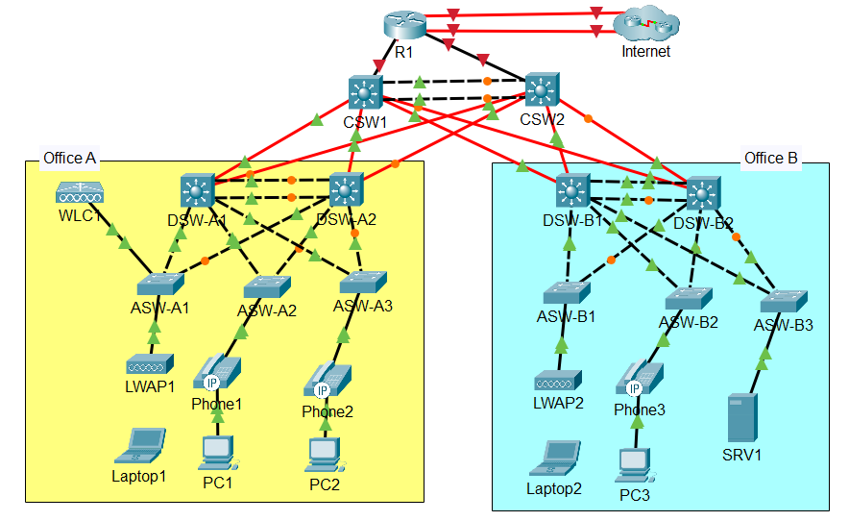

Table of Contents
Introduction 1
1.0 Initial Setup 2
1.1 Hostname 3
1.1.1 Completion 3
1.2 Secret 4
1.2.1 Type 5 Hashing 4
1.2.2 Type 9 Hashing 4
1.3 User Account 5
1.3.1 Type 5 5
1.3.2 Type 9 6
1.4 Timeout and Synchronous Logging 6
2.0 VLANs and EtherChannel 7
2.1 Office A EtherChannel 8
2.2 Office B EtherChannel 10
2.3 Trunk Links 12
2.3.1 Office A 12
2.3.2 Office B 13
2.4 VTPv2 Servers 15
2.5 VLAN Configuration/Propagation Via VTP 17
2.5.1 Office A 18
2.5.2 Office B 18
2.6 Access Port Configuration 19
2.6.1 LWAPs 20
2.6.2 PCs/Phones 21
2.6.3 SRV1 23
2.7 WLC1 24
2.8 Disabling Unused Ports 25
3.0 Layer 3 28

Initial Setup
Initial Setup Includes the following steps
1. Configure the appropriate hostname on each router/switch.
2. Configure the enable secret jeremysitlab on each router/switch. Use type 9 hashing if available; otherwise, use type 5.
3. Configure the user account cisco with secret ccna on each router/switch. Use type 9 hashing if available; otherwise, use type 5.
4. Configure the console line to require login with a local user account. Set a 30-minute inactivity timeout. Enable synchronous logging.

1.1 Hostname
This subsection covers the following objective:
Configure the appropriate hostname on each router/switch.

On each router/switch:
Enable
Configure terminal
Hostname <HOSTNAME>
Do write

e.g. for router R1
enable
configure terminal
hostname R1
do write

1.1.1 Completion
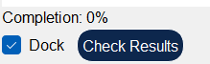
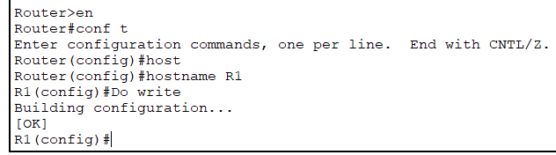
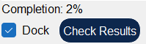
After repeating for all the other switches in the topology with the given hostnames
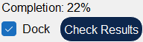

1.2 Secret
This subsection covers the following objective:
Configure the enable secret jeremysitlab on each router/switch. Use type 9 hashing if available; otherwise, use type 5.
The core/distribution switches support type 9 hashing while the other devices only support type 5

1.2.1 Type 5 Hashing
Enable
Configure Terminal
Enable secret <SECRET>
Do write

e.g. for R1:
enable
configure terminal
enable secret jeremysitlab
do write

1.2.2 Type 9 Hashing
Enable
Configure terminal
Enable algorithm-type scrypt secret <SECRET>

e.g. CSW1
enable
configure terminal
enable algorithm-type scrypt secret jeremysitlab

1.3 User Account
This subsection covers the following objective:
Configure the user account cisco with secret ccna on each router/switch. Use type 9 hashing if available; otherwise, use type 5
Type 5 and type 9 hashing availability is the same as for the section that covers secret configuration

1.3.1 Type 5
Enable
Configure terminal
Username <USERNAME> secret <SECRET>
Do write

e.g. for R1:
enable
configure terminal
username cisco secret ccna
do write
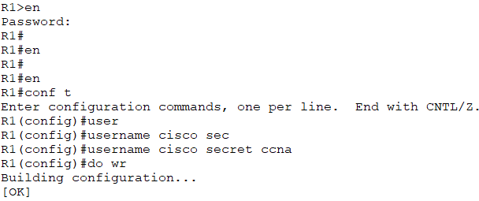
The 5 after secret shows the hashing is type 5

1.3.2 Type 9
Enable
Configure terminal
Username <USERNAME> algorithm-type scrypt secret <SECRET>
Do write

e.g. for CSW1
enable
configure terminal
username cisco algorithm-type scrypt secret ccna
do write
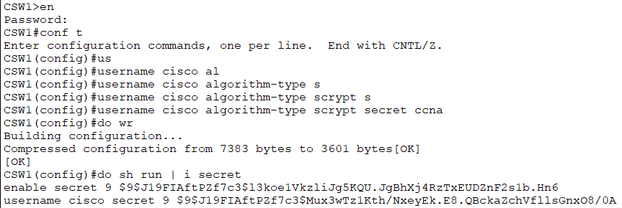
The 9 after secret shows the hashing is type 9

1.4 Timeout and Synchronous Logging
This subsection covers the following objective:
Configure the console line to require login with a local user account. Set a 30-minute inactivity timeout. Enable synchronous logging.
Enable
jeremysitlab
Configure terminal
Line console 0
Login local
Exec-timeout 30
Logging synchronous
Do write
e.g. R1
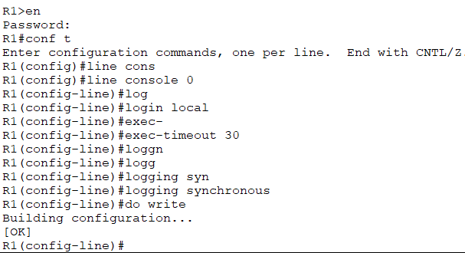
Overall completion has now risen
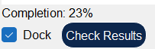

2.0 VLANs and EtherChannel
This part of the lab includes the following steps:
1. In Office A, configure a Layer-2 EtherChannel named PortChannel1 between DSW-A1 and DSW-A2 using a Cisco-proprietary protocol. Both switches should actively try to form an EtherChannel.
2. In Office B, configure a Layer-2 EtherChannel named PortChannel1 between DSW-B1 and DSW-B2 using an open standard protocol. Both switches should actively try to form an EtherChannel.
3. Configure all links between Access and Distribution switches, including the EtherChannels, as trunk links.
a. Explicitly disable DTP on all ports.
b. Set each trunk’s native VLAN to VLAN 1000 (unused).
c. In Office A, allow VLANs 10, 20, 40, and 99 on all trunks.
d. In Office B, allow VLANs 10, 20, 30, and 99 on all trunks.
4. Configure one of each office’s Distribution switches as a VTPv2 server. Use domain name JeremysITLab.
a. Verify that other switches join the domain.
b. Configure all Access switches as VTP clients.
5. In Office A, create and name the following VLANs on one of the Distribution switches. Ensure that VTP propagates the changes.
a. VLAN 10: PCs
b. VLAN 20: Phones
c. VLAN 40: Wi-Fi
d. VLAN 99: Management
6. In Office B, create and name the following VLANs on one of the Distribution switches. Ensure that VTP propagates the changes.
a. VLAN 10: PCs
b. VLAN 20: Phones
c. VLAN 30: Servers
d. VLAN 99: Management
7. Configure each Access switch’s access port.
a. LWAPs will not use FlexConnect
b. PCs in VLAN 10, Phones in VLAN 20
c. SRV1 in VLAN 30
d. Manually configure access mode and explicitly disable DTP
8. Configure ASW-A1’s connection to WLC1:
a. It must support the Wi-Fi and Management VLANs.
b. The Management VLAN should be untagged.
c. Disable DTP.
9. Administratively disable all unused ports on Access and Distribution switches.

2.1 Office A EtherChannel
This subsection covers the following objectives:
In Office A, configure a Layer-2 EtherChannel named PortChannel1 between DSW-A1 and DSW-A2 using a Cisco-proprietary protocol. Both switches should actively try to form an EtherChannel.

The Cisco-proprietary protocol is PAgP (Port Aggregation Protocol) and both switches actively trying to form an EtherChannel means both should be in desirable mode.
On DSW-A1 as an example:
First need to find which interfaces are relevant, done with
Enable
Show CDP neighbors
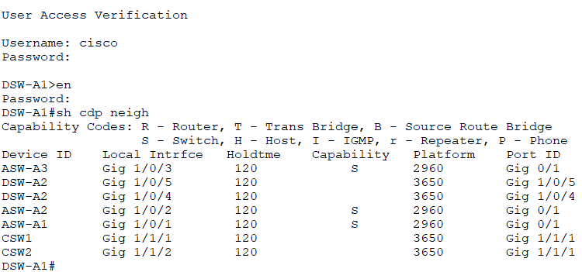
Relevant interfaces are Gig 1/0/5 and 1/0/4, so following off from checking CDP neighbours:
Configure terminal
Interface range gig 1/0/4-5
Channel-group 1 mode desirable
Do write
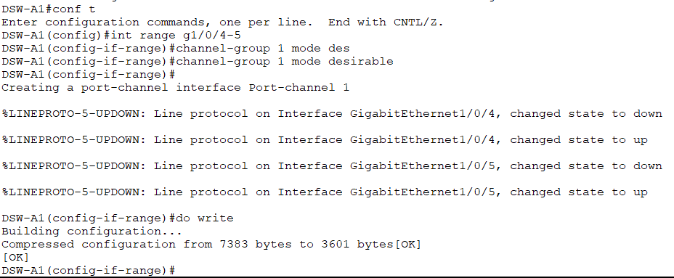
Repeated for DSW-A2
Using do show etherchannel summary we can see that it is in use from the U flag
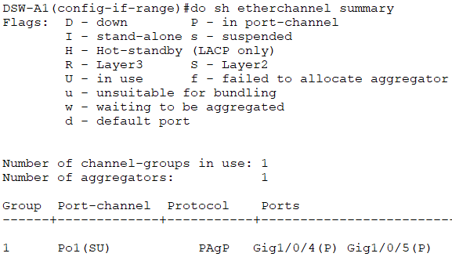

2.2 Office B EtherChannel
This subsection covers the following objectives:
In Office B, configure a Layer-2 EtherChannel named PortChannel1 between DSW-B1 and DSW-B2 using an open standard protocol. Both switches should actively try to form an EtherChannel.

The open standard protocol is LACP (Link Aggregation Control Protocol), both should be trying to form an ether channel so both should be in active mode.

Using DSW-B1 as an example:
Recognising correct interfaces
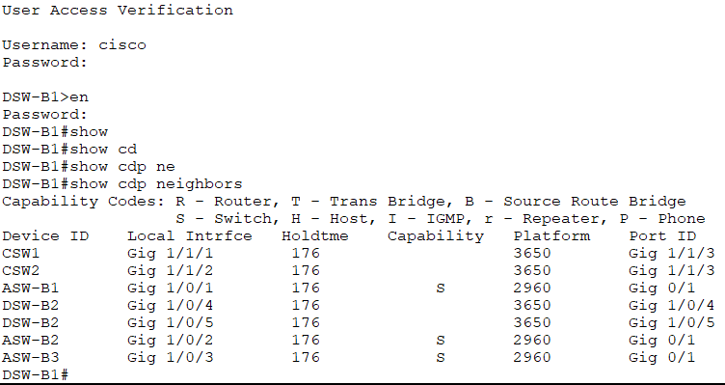
Gig 1/0/4 and 1/0/5

From global configuration:

Configure terminal

Interface range gig 1/0/4-5
channel-group 1 mode active
do write
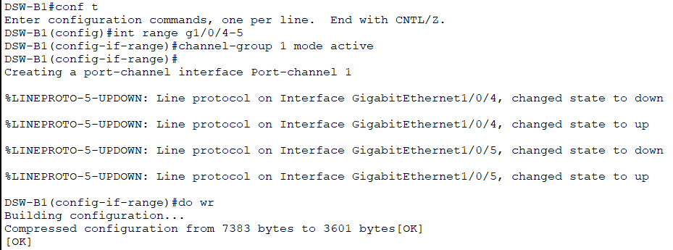
Repeated for DSW-B2
Can see from EtherChannel summary that it is in use from the U flag
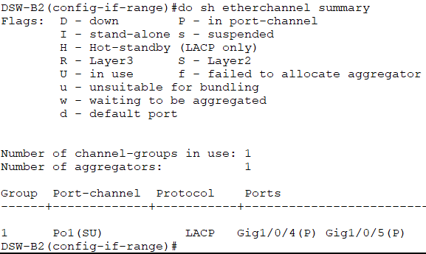

2.3 Trunk Links
This subsection covers the following objectives:
Configure all links between Access and Distribution switches, including the EtherChannels, as trunk links.
a. Explicitly disable DTP on all ports.
b. Set each trunk’s native VLAN to VLAN 1000 (unused).
c. In Office A, allow VLANs 10, 20, 40, and 99 on all trunks.
d. In Office B, allow VLANs 10, 20, 30, and 99 on all trunks.

2.3.1 Office A

Using DSW-A1 as an example:
First we find the relevant interfaces via
Show cdp neighbors
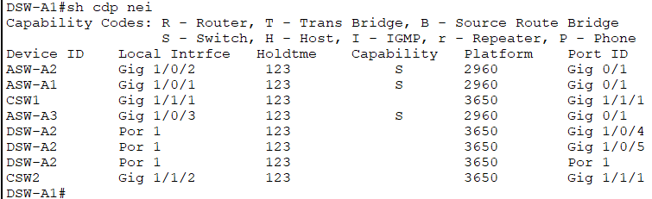
Gig 1/0/1-3 are the relevant interfaces alongside the portchannels

Interface range gig 1/0/1-3
Switchport mode trunk
Switchport nonegotiate
Switchport trunk native vlan 1000
Switchport trunk allowed vlan 10,20,40,99
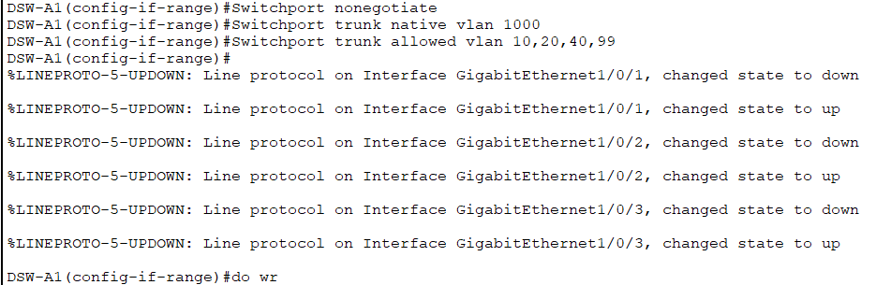
Repeated for the etherchannel, accessed using
Interface port 1
This is then repeated with the access switches
Using ASW-A1 as an example
Show cdp neighbors
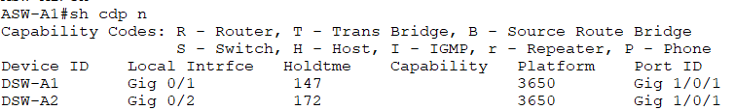
Relevant interfaces are g0/1-2

Interface range g0/1-2
Switchport mode trunk
Switchport nonegotiate
Switchport trunk native vlan 1000
Switchport trunk allowed vlan 10,20,40,99
do write
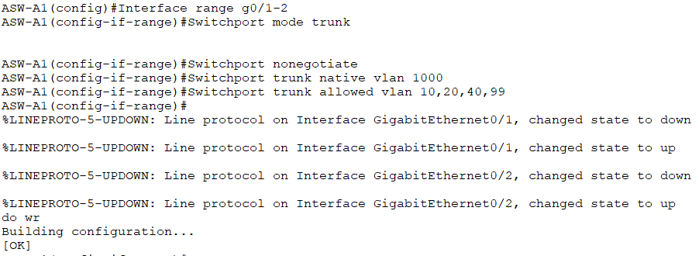

2.3.2 Office B
Office B is the exact same with the exception of allowing VLAN 30 instead of 40
Using DSW-B1 as an example:
Show cdp neighbors
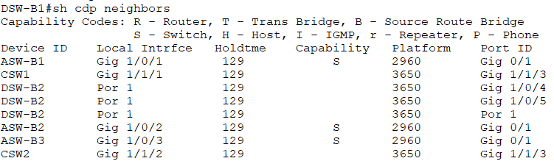
Relevant Interfaces are Gig 1/0/1-3
Interface range gig 1/0/1-3
Switchport mode trunk
Switchport nonegotiate
Switchport trunk native vlan 1000
Switchport trunk allowed vlan 10,20,30,99
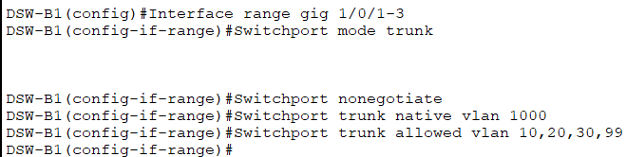
Repeated for interface por 1
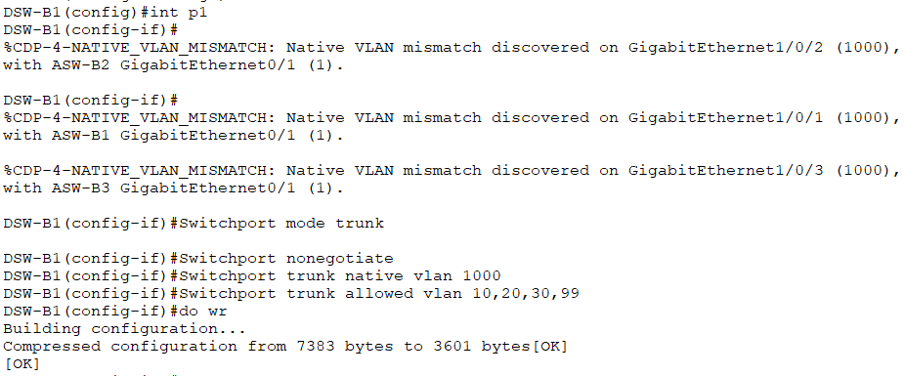

Need to then repeat for the access switches. Using ASW-B1 as an example:
Show cdp neighbors
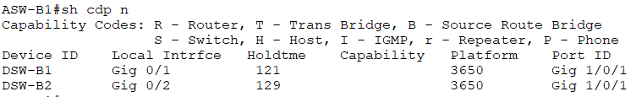
Relevant ports are g0/1-2
Interface range g0/1-2
Switchport mode trunk
Switchport nonegotiate
Switchport trunk native vlan 1000
Switchport trunk allowed vlan 10,20,30,99
do write
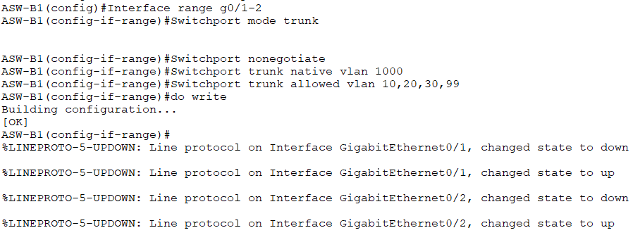

2.4 VTPv2 Servers
The objectives of this subsection are:
Configure one of each office’s Distribution switches as a VTPv2 server. Use domain name JeremysITLab.
a. Verify that other switches join the domain.
b. Configure all Access switches as VTP clients.

On DSW-A1:
Enable
Show vtp status (this shows us the default configuration)
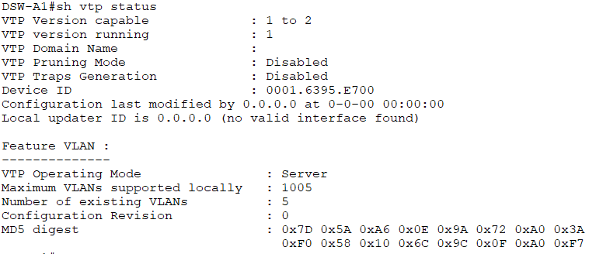
Configure terminal
Vtp domain JeremysITLab
Vtp version 2
Do write
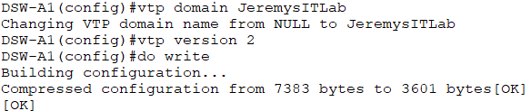
Checking DSW-A2, we can see the changes have propagated
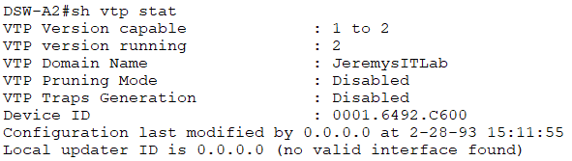
The process is the exact same for office B
Configuration done on DSW-B1
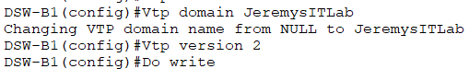
Verifying propagation on DSW-B2
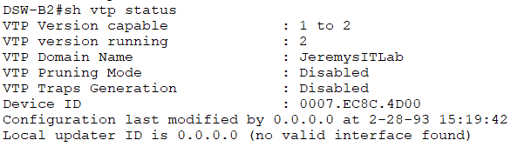
To make all the access switches VTP clients the following command in configure terminal is used:
Vtp mode client
Before
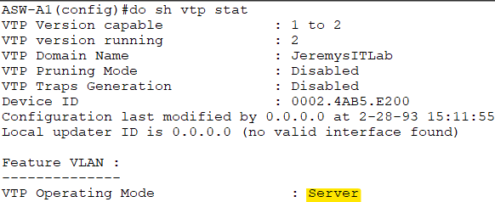
After
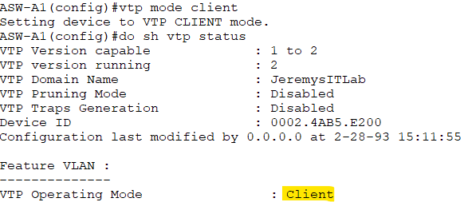
Repeated for every access switch

2.5 VLAN Configuration/Propagation Via VTP
This subsection includes the following objectives:
In Office A, create and name the following VLANs on one of the Distribution switches. Ensure that VTP propagates the changes.
a. VLAN 10: PCs
b. VLAN 20: Phones
c. VLAN 40: Wi-Fi
d. VLAN 99: Management
In Office B, create and name the following VLANs on one of the Distribution switches. Ensure that VTP propagates the changes.
a. VLAN 10: PCs
b. VLAN 20: Phones
c. VLAN 30: Servers
d. VLAN 99: Management

2.5.1 Office A
For each VLAN after configure terminal:
Vlan <VLAN NUMBER>
Name <VLAN NAME>
DSW-A1:
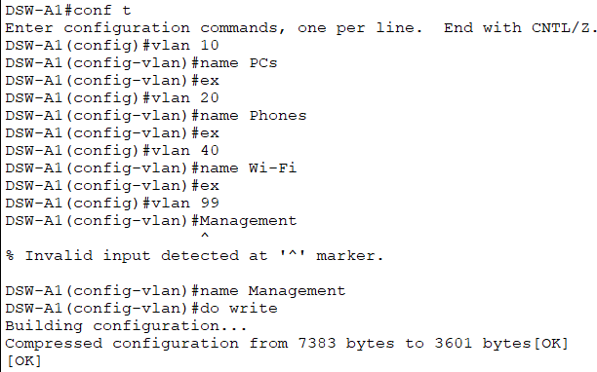
Checking DSW-A2 we can see the changes have propagated
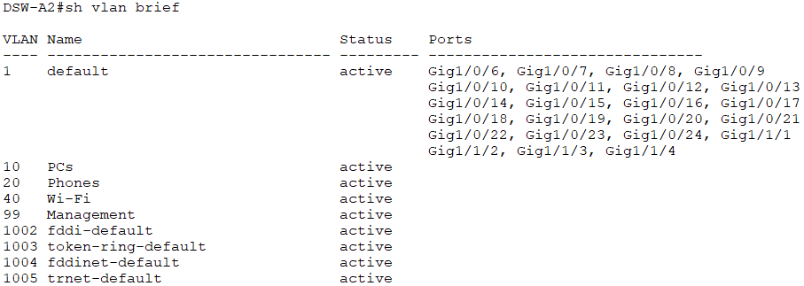

2.5.2 Office B
Exact same as Office A except instead of VLAN 40: Wi-Fi we have VLAN 30: Servers
DSW-B1
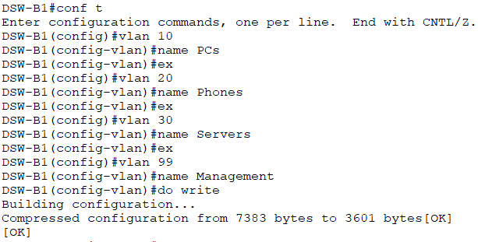
Propagated changes on DSW-B2:
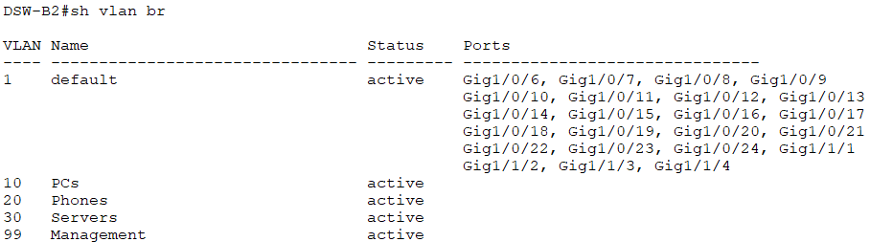

2.6 Access Port Configuration
This subsection covers the following objectives:
Configure each Access switch’s access port.
a. Manually configure access mode and explicitly disable DTP
b. LWAPs will not use FlexConnect
c. PCs in VLAN 10, Phones in VLAN 20
d. SRV1 in VLAN 30

part a applies to every switches access port, it is done via:

enable
configure terminal
interface <RELEVANT INTERFACE>
switchport mode access
switchport nonegotiate

parts b, c and d are specific to switches connected to specific endpoints

2.6.1 LWAPs
The relevant switches here are ASW-A1 and ASW-B1 in this configuration
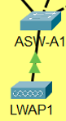
The LWAP doesn’t use CDP so we cant use the show CDP neighbours command to find the correct interface, instead, we take note of its mac address and then use the command
Show mac-address-table
To see which is the relevant interface

Using ASW-A1 as an example:
LWAP mac address
Show mac-address-table
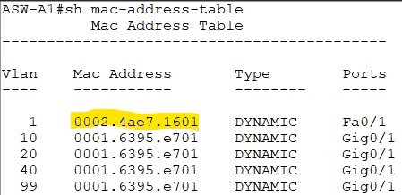
Relevant interface is Fa0/1
Now we have the correct interface we can proceed
Configure terminal
Interface f0/1
Switchport mode access
Switchport nonegotiate
Switchport access vlan 99
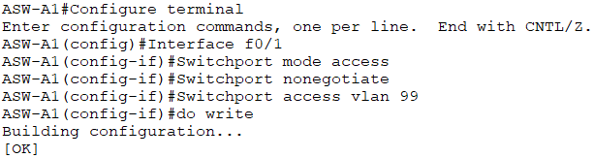
ASW-B1:
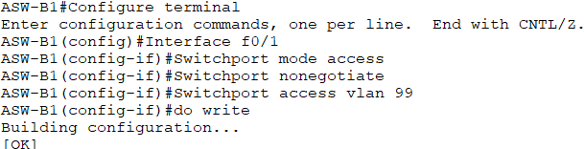

2.6.2 PCs/Phones
Relevant switches are ASW-A2, ASW-A3 and ASW-B2 in the following configuration
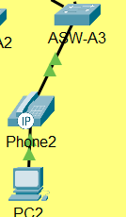
Using ASW-A2 as an example
We first find the relevant interface
Show cdp neighbors gives this output
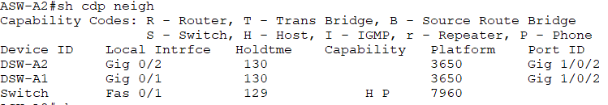
We can see 3 connections, 2 are to the distribution switches and 1 is titled switch
Using show interface status, we can see there are 3 interfaces in use
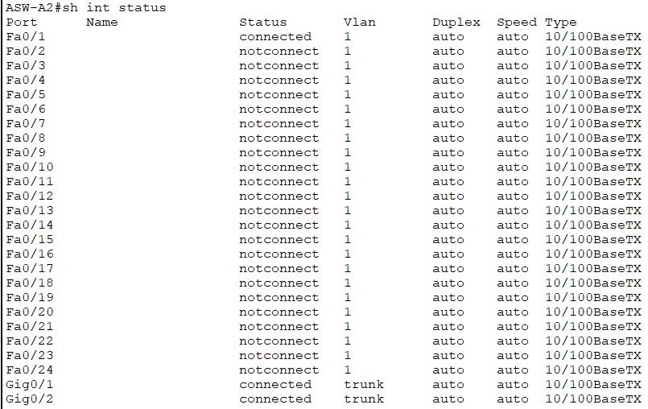
If 2 are being used for connections to the distribution switch connections (the gig interfaces) then the remaining Fa0/1 must be the one connected to the IP phone, continuing on:

Configure terminal
Interface f0/1
Switchport mode access
Switchport nonegotiate
Switchport access vlan 10
Switchport voice vlan 20
Do write
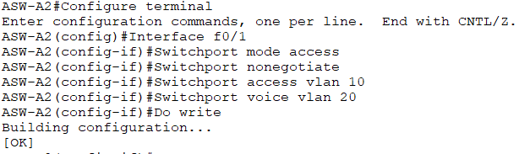
Repeated exactly for A3 and B2 as they also use fa0/1 as their relevant interface

2.6.3 SRV1
The relevant switch here is ASW-B3
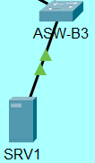
We can easily deduce the relevant interface using the previous approach as from 2.6.2
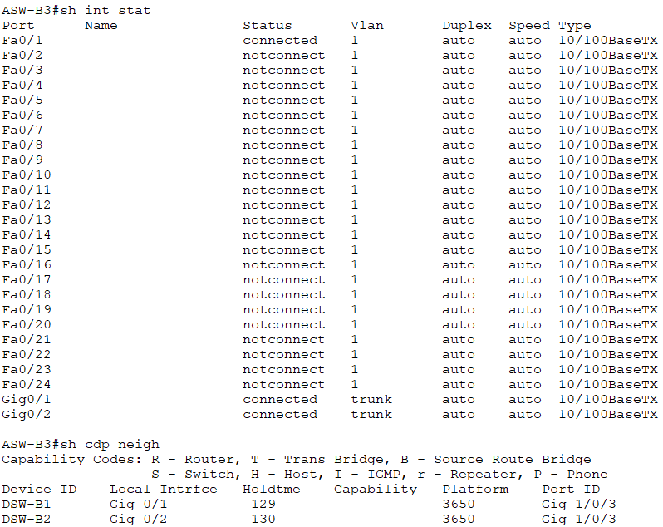
Fa0/1 is the relevant interface, from here:
Configure terminal
Interface f0/1
Switchport mode access
switchport nonegotiate
switchport access vlan 30
do write

2.7 WLC1
This subsection convers the following objectives:
Configure ASW-A1’s connection to WLC1:
a. It must support the Wi-Fi and Management VLANs.
b. The Management VLAN should be untagged.
c. Disable DTP.

This switch was previously configured as it has an LWAP connected
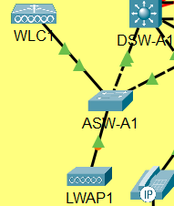
Using show interface status, we get this output
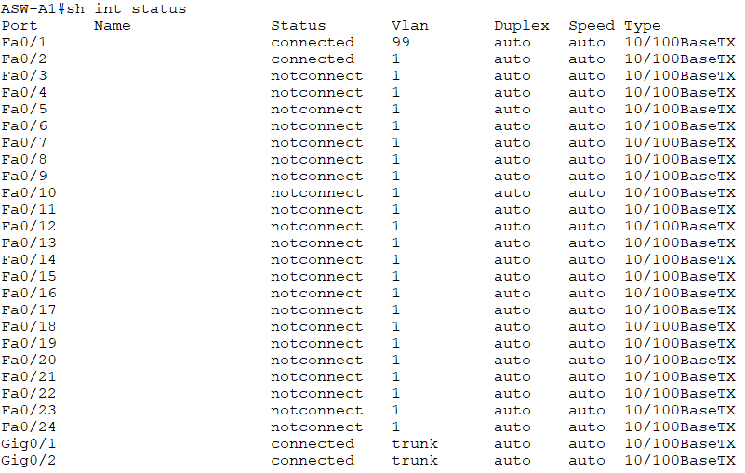
The 2 Gig interfaces are for the distribution switch connection, Fa0/1 is the LWAP connection leaving Fa0/2 as the WLC connection. From here:
Configure terminal
Interface f0/2
Switchport mode trunk
Switchport nonegotiate
Switchport trunk allowed vlan 40,99
Switchport trunk native vlan 99
Do write
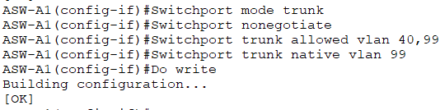

2.8 Disabling Unused Ports
The following subsection covers this topic:
Administratively disable all unused ports on Access and Distribution switches
Using DSW-A1 as an example:
We can check which ports aren’t in use with
Show interface status
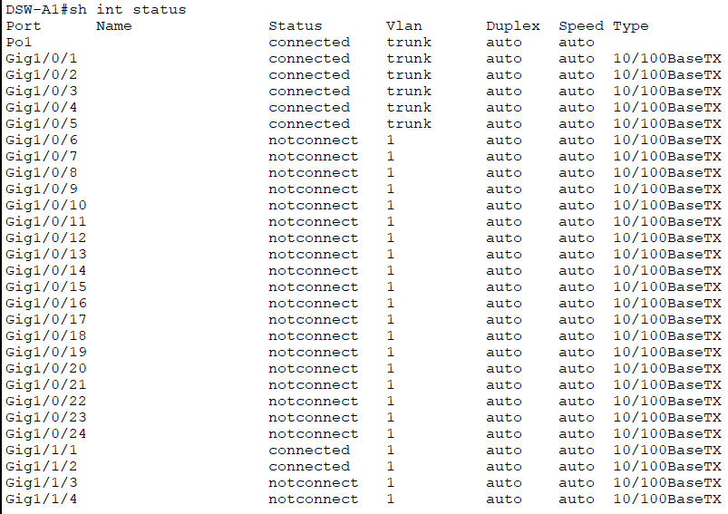
Every port with the notconnect status needs to be disabled
Done with:
Configure terminal
Interface range g1/0/6-24,g1/1/3-4
Shutdown
Do write

Interface status output shows it was successful
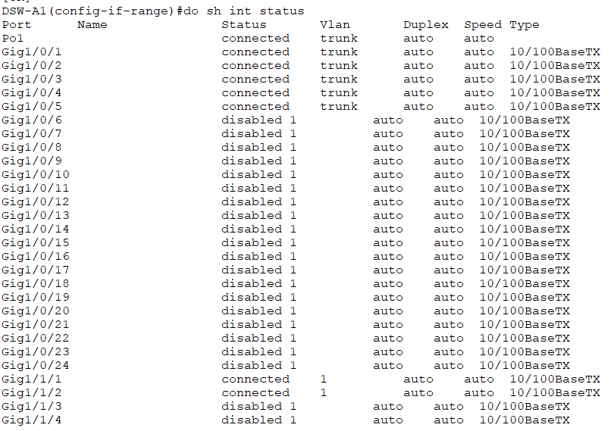
Process repeated with every switch
Example using an access switch (ASW-A1):
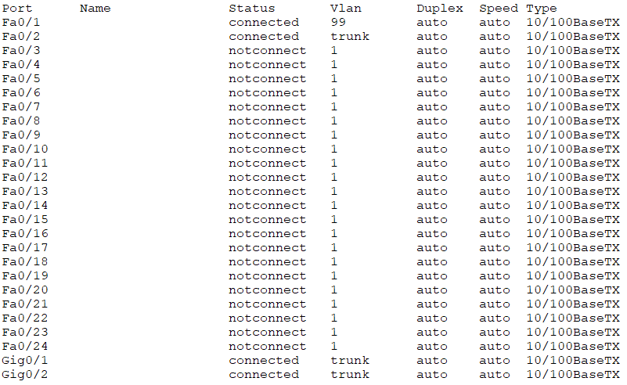
Configure terminal
Interface range f0/3-24
Shutdown
Do write
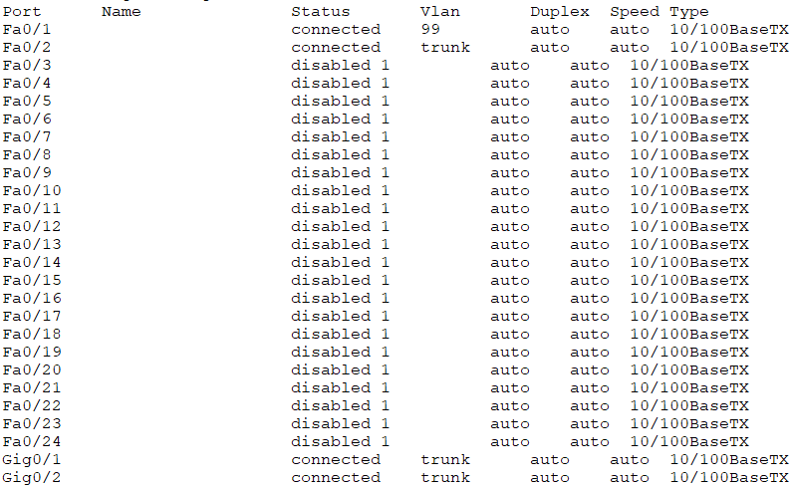
ASW-A1 has 4 connection vs every other access switches 3 so the interface range is different, including 1 extra interface
Configure terminal
Interface range f0/2-24
Shutdown
Do write
That is Part Layer 2 complete, completion change:
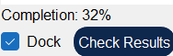
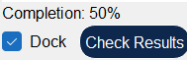

3.0 Layer 3

